My Payslip PDF generation Process - Penetration test

Analyze how the application loads PDF - through requests or through function calls

Find what generates the PDF ?

is the application doing server side PDF generation ? - common in java , node , PHP , Python

identify :

check whether you can get a network request - see direct response - No no direct response is available

Frontend jacaScript triggers a PDF generator API

Identify: Check DevTools - JavaScript call Like fetch ("/app/url/pdf") or window.open()

Link button creates hidden form submission event ?

what to check ?

open chrome

trigger download

request the path

- GET method
- Request Headers / Query parameters
Response MIME type :application/pdf
Prevoew/ Response Tab - raw PDF stream

Revealk the javascript function troggering it

- go for event listerenrs

- click click linked script - take syou to the generating function in JS source

or run

getEventListeners(document.querySelector("button or element"))

Interact with it through JavaScript Console

- button onclick="generate" - then access the function from the console

- check whether it is an XHR/Fetch call replicate from console using the code

fetch("/app/url/pdf")
.then(r => r.blob())
.then(b => console.log("PDF Blob:", b));

To Save the file

fetch("/app/url/pdf")
.then(r => r.blob())
.then(b => {
let url = URL.createObjectURL(b);
window.open(url);
});

Application has a request but is not having any parameters to be passed onto the request

Proceeding with the DOM based and function cal check

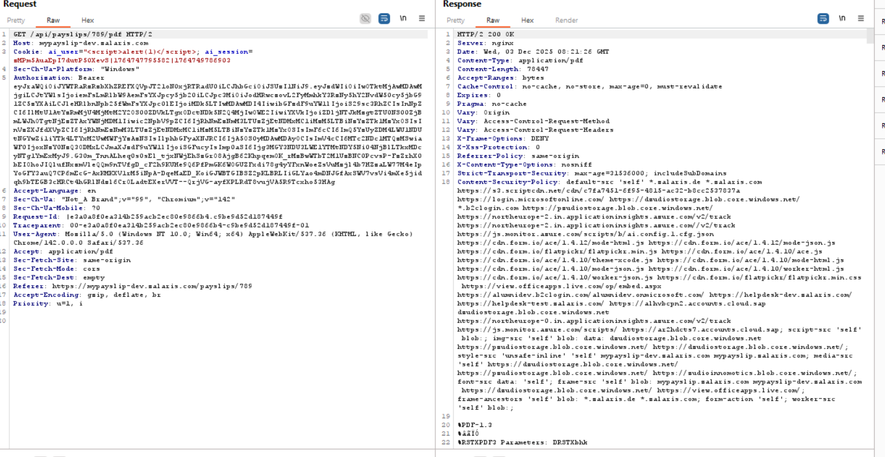

Screenshot shows that no parameters are passed

Moving onto DOM tests
The function calls are not accepting the value from the user - this prevents the scope of DOM injection in the PDF process.

Look for local / sessison storage -

No Values are in local or session storage - but one value is processed in the Local Storage

SelectedPayslipYear

Here the following values give different output

Numeric Boundary & Type Validation

-1 is returned as 00-1
9999 makes the application give invalid date in the year field

Further payloads are tested now

Negative maximum - -999999

Returns INvalid Date

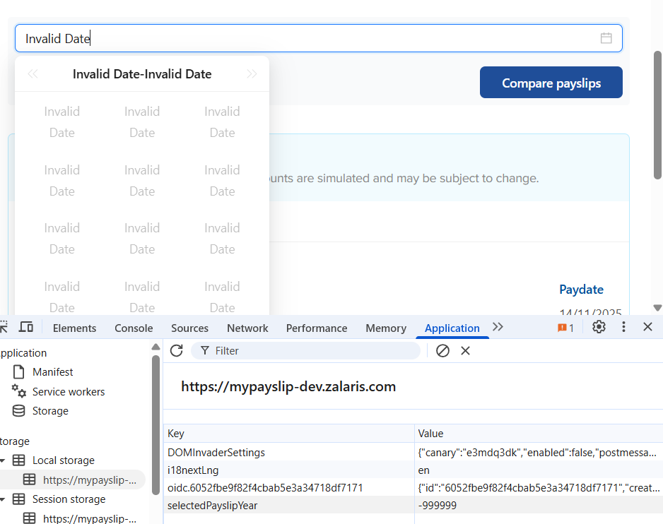

Zeroes - no abnormal response

Exponential notation gives abnormal response - 1e10

Hex Values are decoeded by the application or the browser and is passed onto the applcation - value 0x2025 is converted to 8229

Screenshot is attached below

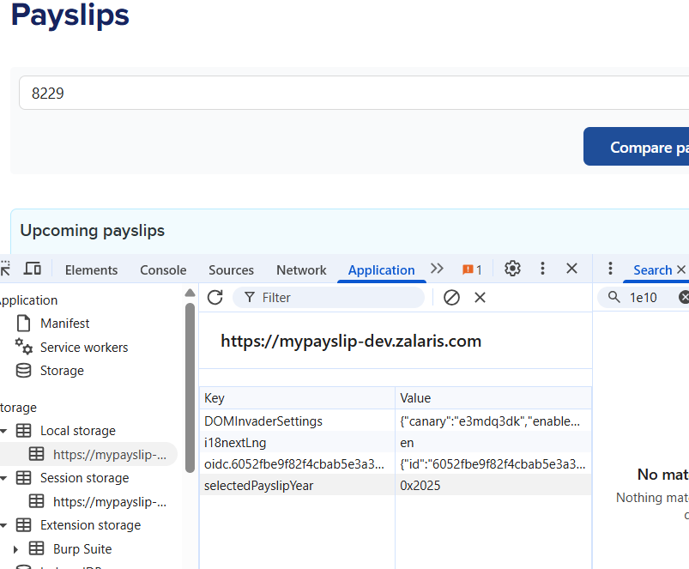

NaN and special Numbers

NaN - no abnormal reponse

Infinity - application crashed - internally need to check in the burp for the request made
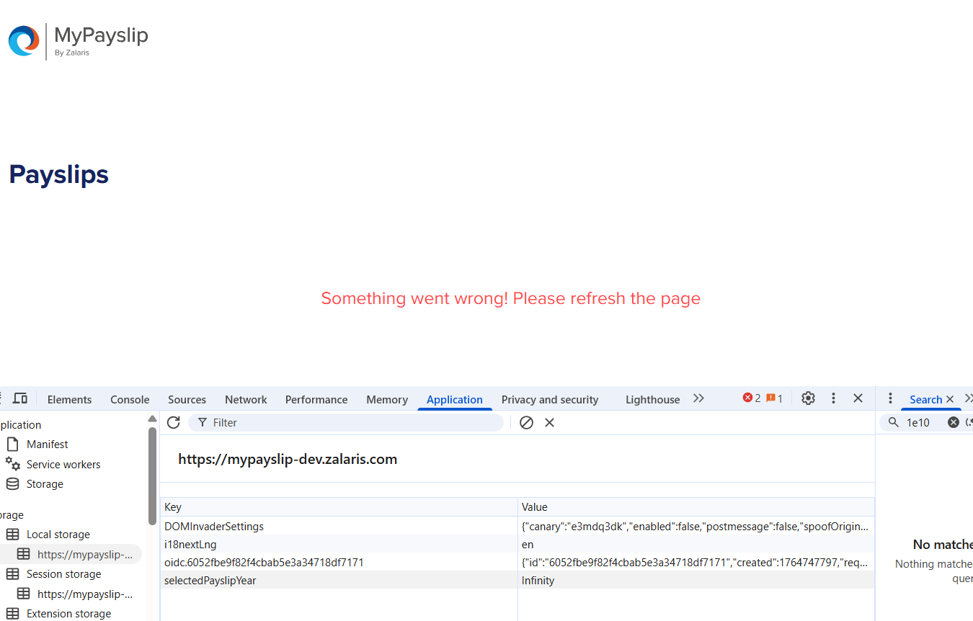
2️⃣ Type Confusion Attacks

Test | Payloads
Year as string | "2023"
Array | [], ["2023"], [1,2,3]
Object injection | {}, {"year":2025}
Null/Boolean | true, false, null, undefined
Whitespace | " ", " 2022"

Year as string -no abnormal response received

Array - No abnormal response found

Object injection - no abnormal respose found
Null Boolean - No abnormal response found
Whitespace - No abnormal response found

Client-Side Code Injection

Attack Type | Payloads
XSS test | <img src=x onerror=alert(1)>, <script>alert(1)</script>, "><svg/onload=alert(1)>
Event handler payload | " onfocus=alert(1) "
HTML break-out | 2022</span><script>alert(1)</script>

No abnormalResponse was found

Logical Manipulation

Logic Abuse | Payloads
Future boundary | 30000, 9999
Epoch edge | 1970, 1900, 0000
SQL injection if value reaches backend | 2022 OR 1=1, ' OR '1'='1
Directory traversal encoded | %2e%2e%2f

No abnormal response detected

5️⃣ Unicode & Encoding Attacks

Payloads
％２０２２ (full-width characters)
Emoji: "🎯", "🗓️2022"
RTL override: 2022‮
Non-breaking space: 2022

Payloads are not valid test cases

6️⃣ Serialization / Prototype Pollution

Payloads
__proto__
{"__proto__":{"polluted":"yes"}}
{"constructor": {"prototype": {"polluted": "yes"}}}

No abnormal response received

Crash / Performance Payloads

Payloads
"1".repeat(10_000_000)
JSON bomb: [[[[[...] ]]]] deeply nested objects
Very long string: "A" * 500000

No abnormal response was received do far tested

CSRF not possible due to authorization token

